‘Lincoln Tenants’ Panel and City of Lincoln Council

Appendix A

Tenant Involvement Strategy 2022-2025

Foreword from the Tenants’ Panel Chair

“The Lincoln Tenants’ Panel support this Tenant Involvement Strategy and welcome the many opportunities it brings for tenants and leaseholders to have their say about how services are provided over the next three years and beyond. The information used to develop this strategy has been sourced based on our joint experience with tenants, best practice, legislation and guidance from our government.”

“Lincoln Tenants’ Panel has dedicated a lot of time in shaping services and will continue to do this.”

Foreword from the Council’s Portfolio Holder for housing

We are grateful to our Tenants’ Panel for the time and effort they have given in helping understand the needs and aspirations of tenants. We continue to work closely together, sharing information and developing our housing service. Transparency with our tenants is very important to us and we have a very challenging future ahead of us. “

Introduction

The delivery of an excellent housing service requires high levels of performance, value for money and tenant satisfaction. In 2018 (the year our latest tenant satisfaction survey was undertaken) 86% of tenants reported that they were either very or fairly satisfied with the overall service received.

Coronavirus (COVID-19) Pandemic

The Coronavirus pandemic has caused major disruption and has led to a range of lock down measures to tackle the spread of the virus. These restrictions have changed the ways in which we operate and have limited our ability to interact with and serve customers.

Many of our contractors and suppliers have been affected and this has led to delays in many projects and programmes of work. We continue to monitor and respond to the situation. However, it is unlikely that we will return to the ‘old normal’ and will need to develop new and better ways to deliver housing services.

The new Tenant Involvement Strategy works closely with the Vision 2025 document, the City of Lincoln Council’s strategic plan that sets out our long-term vision of:

“Together, let’s deliver Lincoln’s ambitious future”

It also sets out the council’s strategic priorities:

- Let’s deliver quality housing
- Let’s drive economic growth
- Let’s reduce inequality
- Let’s enhance our remarkable place
- Let’s address the challenge of climate change.

The Tenant Involvement Strategy will help contribute to meeting Vision 2025 by helping to ‘deliver quality housing’ as well as contributing to the other strategic priorities set out above. The next section goes into further detail and expands on these points.

Why do we involve tenants?

Involving tenants and residents is crucial in helping us to deliver outstanding housing services and without their input it would be difficult to provide quality services to tenants that meet their expectations.

The principles of effective involvement are that tenants and residents can:

- Have a choice that matters
- Help to get services right for all
- Hold the council to account for the decisions made
- Empower themselves through learning new skills and gain experience
- Empower communities through involvement.

A new charter introduced by the Government, the Charter for social housing residents (government Social Housing White Paper 2020) sets out what every social housing tenant should expect from their council:

To be safe in your home
To know how your landlord is performing
To have complaints dealt with promptly and fairly
To be treated with respect
To have your voice heard by your landlord
To have a good quality home and neighbourhood to live in
To be supported to take a step to ownership

New tenant satisfaction measures to be introduced by the Government

New tenant satisfaction measures are being introduced to assess how well we are performing against the standards. These are:

Theme

Overall | - Tenant satisfaction with overall service
Keeping properties in good repair | - Homes that do not meet the Decent Homes Standard (DHS). The DHS requires homes that are warm, weatherproof and have reasonably modern facilities  - Repairs completed within target timescales  - Tenant satisfaction with repairs  - Tenant satisfaction with time taken to complete most recent repairs
Maintaining building safety | - Gas safety  - Fire safety  - Asbestos safety  - Water safety  - Lift safety  - Tenant satisfaction that home is well maintained and safe to live in
Effective handling of complaints | - Number of complaints received  - Complaints responded to within Complaint Handling Code timescales  - Tenant satisfaction with landlord's approach to handling of complaints  - Tenant knowledge of how to make a complaint
Respectful & helpful engagement | - Tenant satisfaction that the landlord listens to views and acts on them  - Tenant satisfaction that the landlord keeps tenants informed about things that matter to them  - Agreement that the landlord treats tenants fairly & with respect
Responsible neighbourhood management | - Number of Anti-social behaviour (ASB cases)  - Tenant satisfaction that the landlord keeps communal areas clean, safe, and well maintained  - Tenant satisfaction that the landlord makes a positive contribution to neighbourhoods  - Tenant satisfaction with the landlord’s approach to handling of ASB

The Existing Regulatory Framework and the White Paper

Under the existing regulatory framework and this white paper, we are committed to making this happen.

Some of the standards set out in the existing regulatory framework that relate to involving tenants include:

- Supporting the formation and activities of tenant panels or equivalent groups and responding in a constructive and timely manner to them
- Consulting with tenants about services by setting out clearly the costs and benefits of relevant service options and changes to services
- Consulting tenants at least once every three years on the best way of involving tenants in the governance and scrutiny of the organisation’s housing management service
- Tenants should be given the opportunity get involved in:

  - their landlord’s housing related policies and strategic priorities

  - making decisions about how housing related services are delivered, including the setting of service standards

  - scrutinising performance and making of recommendations to their landlord about how performance might be improved
In addition to this, revised consumer standards from the white paper are:

Safety
Landlords’ safety responsibilities including safety within the home and in communal areas

Quality
Quality of the home, communal spaces, and services to tenants.

Neighbourhood
Landlords’ role, working with other agencies to contribute to the wellbeing of neighbourhoods in which tenants live

Transparency
Landlords’ role in making information accessible to tenants including roles and responsibilities within landlords, so tenants know who is responsible for matters relating to consumer standards.

Engagement and accountability
Engagement between landlords and tenants, including how complaints are handled. Landlords’ accountability to tenants and treating tenants with fairness and respect

Tenancy
Requirements on landlords in respect of tenancies, including allocations policies and opportunities for tenants to move

How the Government will ensure we comply with the standards set out above

The Government wants to

- See a transformed consumer regulatory regime which holds landlords to account in maintaining good quality homes and services, prioritising safety, treating tenants respectfully and being transparent with information. In short, our housing service will be inspected

- Retain the principle of co-regulation, as it ensures that the focus is on driving good outcomes for existing and future tenants

- Introduce new regime for regulating social housing. This will give tenants confidence that their landlord is being properly scrutinised

- Put safety at the heart of social housing regulation

- Make social landlords more transparent and accountable

- Strengthen the regulator’s powers to enforce

Building and Fire Safety

Following the tragic events of the Grenfell fire in 2017, the Government introduced several measures to improve fire and building safety especially in high rise blocks and buildings of multiple occupancy.

Building and fire safety reforms are currently coming into force alongside the white paper.

These reforms are being developed to help ensure your home is safe and that you feel safe.

A Building Safety Engagement action plan has been developed to look at getting ‘buy in’ for tenants and leaseholders living in flats by ensuring fire safety management and emergency plans are enacted, we need to find innovate ways of engaging with tenants and leaseholders.

Bringing it all together

This chart shows how the government wants to bring everything together:
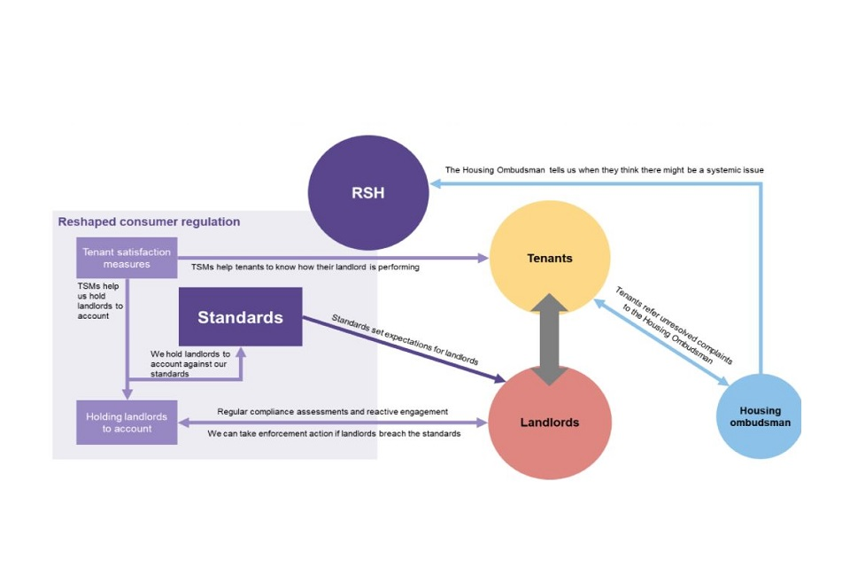
What these things mean

Housing Ombudsman
Resolve complaints and disputes between individual residents and landlords​

Regulator of Social Housing
Ensures the social housing sector is well run, viable and can deliver homes for residents​. Sets standards for landlords and can act if they are breached​.

Building Safety Regulator​
Will help ensure residents of all high-rise buildings are safe​.
Will oversee safety and performance of all buildings.

Department for Levelling Up, Housing and Communities​
Puts forward legislation​. Directs regulators and Ombudsmen​
Sets rent rules

Tenant and leaseholder involvement is crucial to implementing the changes and we have set out how we intend to do this over the next 3 years within this strategy and in consultation with our Tenants’ Panel.

Our Vision for our new strategy is to:

‘To provide a range of ways for tenants and leaseholders to get involved and using this to co-design of services and improvements.’

Our Objectives:

We have agreed five objectives for our Tenant Involvement Strategy. These are:

- Co-design services with residents
- Facilitate community engagement
- Communicate key messages to residents
- Co-regulate with Lincoln Tenants’ Panel
- Expand the ways residents can get involved

Involving tenants and leaseholders in these ways will help us to jointly deliver the top priorities identified.

We have developed an action plan which we intend use to help us achieve our objectives which can be found at the end of this document.

We have also consulted with tenants and leaseholders to find out what they see as their top priorities:

Top priorities for Tenants

- Improving services
- Investing more in home and estate improvements
- Building new council houses
- Improving the estate environment

Top Priorities for leaseholders

- Improve communication to ensure leaseholders views are taken into account
These priorities are also reflected in the council’s overall vision 2025 to deliver quality housing

- Let’s provide housing which meets the varied needs of residents
- Let’s improve housing standards for all
- Let’s build thriving communities
- Let’s help people have a sense of belonging
- Let’s ensure our development approach reduces our carbon footprint
- Let’s set the Lincoln Standard for sustainable zero carbon development

What have we achieved so far?

Our annual report to tenants continues to be published so tenants and leaseholders can keep up to date with our achievements and performance, however publications will timelier and generally provided digitally, removing the need to publish at set intervals. They detail house building, improvements (Decent Homes and Lincoln Standard of housing), scheduled and responsive repairs, tenancy management including tenancy breaches, anti-social behaviour, rental income and the estate environment, as well as tenant involvement in these activities.

Since the launched our last tenant involvement strategy and despite the coronavirus pandemic, we are proud of what we have achieved to improve our tenant involvement service and the willingness of tenants and leaseholders to participate in this.

Tenants and leaseholders have contributed in many of the ways set out in our menu of involvement (see below). The pandemic has encouraged the use of digital communication, such as Facebook and Zoom, and made it easier for people to get involved.

We have also reached out to people through fun days and roadshows, which has enabled even more people to get involved and influence how services are delivered as well as gain their views on our agreed future plans.

Our menu of involvement

There are many ways in which tenants and leaseholders can become involved and these can be tailored to suit everyone. Our menu of involvement shows some of the options available:

- Lincoln Tenants’ Panel, focus groups and forums
- Consultation and satisfaction surveys
- Mystery shopping
- Estate and tenant inspections of services
- Community and resident groups and their representatives/spokes person
- Community projects
- Consultations, events and roadshows
- Home magazine and the Annual Report to tenants, including writing and editing for these
- Following, commenting and messaging us via our social media channels . Facebook page: City of Lincoln Council – Resident Involvement

Support for tenant and resident involvement

New technology presents exciting opportunities, and we will take full advantage of this.

Training and support are in place to help anyone who wants to get involved from IT skills and support with out of pockets expenses, travel costs, catering to childcare costs. Tenants are encouraged to talk to the resident involvement team about their learning and support needs to enable them to participate in any of our involvement options.

Reward vouchers are also available to our Tenant Panel Members and for other involvement activities.

We are always willing to discuss new ways tenants and leaseholder can get involved as we understand that ‘one size’ does not fit all. Timing, accessibility and creating an inclusive and co-ordinated strategy allows us to meet the aspirational outcomes together.

In addition, we have a dedicated resident involvement team who will co-ordinate resident involvement across the organisation and provide support for involved tenants.

Recruitment

Successful delivery of the strategy will also require sufficient numbers of tenants being involved. It is therefore critical that efforts are made to retain those already taking part and to recruit new tenants to the groups.

Equality, Diversity and Human Rights Statement

The Public Sector Equality Duty means that the Council must consider all individuals when carrying out their day-to-day work, in shaping policy, delivering services and in relation to their own employees.

It requires that public bodies have due regard to the need to:

- Eliminate discrimination
- Advance equality of opportunity
- Foster good relations between different people when carrying out their activities

Our tenant involvement strategy does not discriminate and aims to involve tenants and leaseholders regardless of their age, gender, sexual orientation, race, culture, beliefs, or disability.

Climate Change

The Council is committed to working with tenants and leaseholders to find new solutions to reduce carbon emissions. Our repairs service, and investment in our housing stock can have a significant impact on climate change locally. Reducing carbon emissions is a big challenge for our housing service, now and in the future.

Our commitment to addressing climate change sets out our objectives.

- Let’s ensure our development approach reduces our carbon footprint
- Let’s set the Lincoln standard for sustainable zero carbon development
- Let’s make walking, cycling and the use of public transport the best and favourite way to move around Lincoln
- Let’s ensure the city’s infrastructure is fully adaptable and resilient to the challenges of climate change
- Let’s make our existing housing and business premises energy efficient

Practical tips and ways to get involved can be found in our Climate Change Commission at (www.lincolnclimate.org.uk)

Delivering and monitoring outcomes of the strategy

The resident involvement team will take the lead in its delivery. Throughout the lifetime of the strategy the resident involvement team will review the strategy with Lincoln Tenants Panel to ensure the objectives are being met and activities are providing value for money.

Housing Scrutiny Sub Committee and housing managers will receive updates about progress and have the opportunity to provide input into the strategy.

The Lincoln Tenants’ Panel will assess the progress of the strategy using a rating system as follows:

Gold Silver Bronze Red Flag

As part of the launch of our strategy Lincoln Tenants Panel have carried out an initial assessment to give us a starting position against which we can monitor outcomes.

Feedback on the strategy

We welcome you views on our resident involvement strategy. You can:

-  email us at: LTP@lincoln.gov.uk

-  phone us on 01522 873398

-  visit us at Facebook-search City of Lincoln Council-Resident

Involvement.

Appendix A-Action Plan

Objective | Action | Lincoln Tenants’ Panel Assessment
Co-design services with residents  Expand the way residents can get involved | Housing Revenue Account Business Plan  Involve tenants and leaseholders to review Housing Revenue Account Business Plan and delivery plan  Agree on what tenant and leaseholder involvement is needed to successfully deliver any actions | 
 | Ensure that internal procedures for involving tenants in decision making are fit for purpose, for example, any decisions taken demonstrate the level of tenant involvement in the process leading to the decision made
 | Continue to resource tenant involvement:  Agree the level of tenant involvement and the level of resources that should be available to deliver service changes | 
 | Review customer feedback and use it to improve services, ensuring a record is kept demonstrating how feedback has been used.
 | Carry out consultation with residents on the estate improvement programme
 | Develop and deliver the building safety engagement strategy and deliver the actions set out within it
 | Develop an on-line training module for tenants and staff to educate the importance and requirement for tenant involvement in service delivery and development.
 | Support joint working opportunities for tenants to share best practice with other social landlord tenants and supporting bodies.
Objective | Action | Lincoln Tenants Panel  Assessment
Facilitate community involvement | Neighbourhood and Community groups  Promote wider community involvement and target hard to reach groups such as leaseholders and young people to get involved in housing services
Facilitate community involvement | Gain feedback from the neighbourhood boards and community groups to inform service improvement
Facilitate community involvement | Assist in the delivery of community projects as agreed within the housing service plan | 
Facilitate community involvement | Involve tenants and leaseholders from community groups in involvement activities
Facilitate community involvement | Support tenant representatives to support community groups in their areas

Objective | Action | Lincoln Tenants Panel Assessment
Communicate key messages and increase digital engagement  Expand the ways residents can get involved | Implement a continuous reporting model for performance by increasing the frequency and methods used to publish information
Home Magazine

Publish timely information throughout the year and publish this digitally and in user friendly formats

Annual Report

Publish timely performance data and the Annual Report to Tenants each year and publish this digitally and in user friendly formats

 | Help volunteers to use platforms, such as Zoom and Microsoft Teams to give better access to involvement opportunities
 | Creatively and continually develop our menu of involvement
 | Ensure our menu of involvement is inclusive and allows tenants with specific needs to take part and promote equality and diversity throughout the housing service
Objective | Action | Lincoln Tenants Panel Assessment
Co-regulate with Lincoln Tenants Panel | Continue to support and develop LTP  Agree annual workplan with agreed officer attendance as required  Implement the revised constitution
Co-regulate with Lincoln Tenants Panel | Agree and implement a programme of reviews into areas of the service where LTP have concerns about improvements
Co-regulate with Lincoln Tenants Panel | Carry out joint inspections of sample voids properties to check that they are at the expected standard before letting (voids are the current vacant properties)
Co-regulate with Lincoln Tenants Panel | Review complaints to inform service improvements
Co-regulate with Lincoln Tenants Panel | Jointly monitor performance through Housing Scrutiny Sub Committee
 | Develop an annual planner for involvement activities and training and monitor its delivery

Appendix B-Risks that threaten delivery of the strategy

There are a number of risks that could potentially threaten full delivery of the strategy. These have been set out in the table below.

Risk | Consequence | Controls in place
Lack of residents involved | Insufficient numbers involved result in groups not running or operating effectively | Recruitment plan in place that continually recruits tenants.  Quickly address issues that might cause involved tenants to leave
Members of staff not complying with resident involvement duties/guidelines | Residents not consulted or involved, leading to complaints and potentially leading to a regulatory breach. This could also lead to a legal challenge | Staff awareness training to be carried out
Key involved residents leave e.g. LTP chairperson | Groups lose leadership and/or coordination and stop running | Succession plans to be put in place for key groups
Disagreements between involved residents | Groups stop running for a period of time or completely collapse | Adequate terms of references in place.  Resident involvement team to provide mediation
Weak or no terms of reference in place for groups | Groups are not able to run due to a lack of clear processes in place | Resident involvement team to offer advice to groups on terms of references
Insufficient budget in place | Lack of a budget would mean groups could not pay for meeting rooms, equipment, or training. This could severely restrict their ability to operate | Resident Involvement team and LTP to monitor the involvement budget

